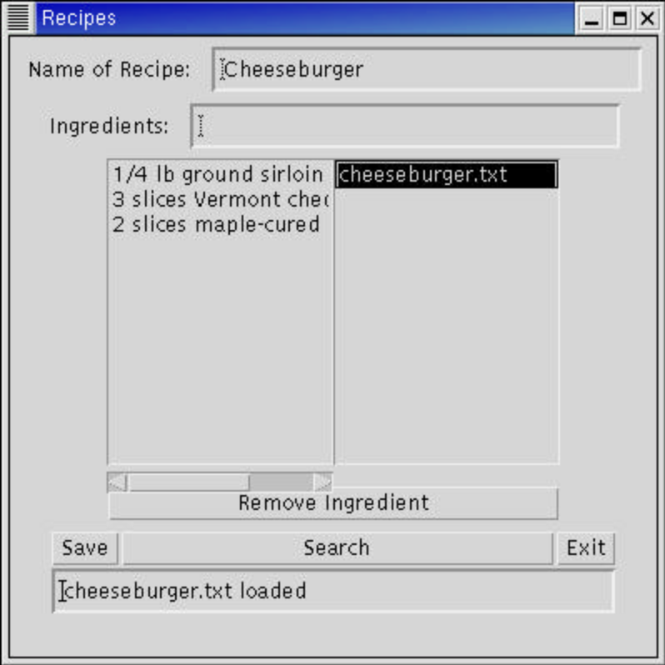
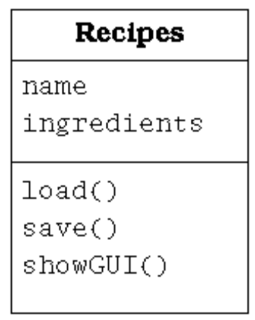
NAME=Cheeseburger
INGREDIENTS=3
1/4 lb ground sirloin
3 slices Vermont cheddar cheese
2 slices maple-cured bacon
006
007class Recipes extends Frame {
008
009 private Label titleLabel = new Label("Name of Recipe:", Label.LEFT);
011 private TextField titleText = new TextField(30);
012
013 private Label ingredientsLabel = new Label("Ingredients:",Label.LEFT);
015 private TextField ingredientsText = new TextField(30);
016
017 private Button ingredientsRemoveSel = new Button("Remove Ingredient");
019 private List ingredientsList = new List(12, false);
020 private List searchList = new List(12, false);
021
022 private Button saveButton = new Button("Save");
023 private Button searchButton = new Button("Search");
024 private Button exitButton = new Button("Exit");
025 private TextField statusText = new TextField(40);
026
027 public void loadFile() {
028 statusText.setText(searchList.getSelectedItem());
029
030 try {
031 BufferedReader in = null;
032 String thePath;
033 thePath = "recipes/" + searchList.getSelectedItem();
034 in = new BufferedReader( new FileReader(thePath));
036 String line;
037 while ((line = in.readLine()) != null){
038 int pos = line.indexOf('=');
039 String token = line.substring(0, pos);
040 String value = line.substring(pos+1);
041 if (token.equals("NAME")) {
042 titleText.setText(value);
043 } else if (token.equals("INGREDIENTS")) {
044 int num_lines = Integer.parseInt(value);
045 for (int i=0; i < num_lines; i++) {
046 line = in.readLine();
047 ingredientsList.add(line);
048 }
049 }
050 }
051 in.close();
052 } catch (IOException e) {
053 System.err.println(e);
054 statusText.setText(searchList.getSelectedItem()+ " is corrupt");
056 return;
057 }
058 statusText.setText(searchList.getSelectedItem()+ " loaded");
060 }
061
062 public void removeSel() {
063 int count;
064 String str;
065 str = ingredientsList.getSelectedItem();
066 if (str != null) {
067 count = ingredientsList.getSelectedIndex();
068 ingredientsList.remove(count);
069 }
070 }
071
072 public void addIngredient() {
073 String str;
074 str = ingredientsText.getText();
075
076 if (str.length() != 0) {
077 ingredientsList.add(str);
078 ingredientsText.setText("");
079 }
080 }
081
082 public void exit() {
083 dispose();
084 System.exit(0);
085 }
086
087
088 public void saveFile(File theFile) {
089 try {
091 PrintWriter out = new PrintWriter( new FileWriter(theFile));
094 out.println("NAME=" + titleText.getText());
096 int counter = ingredientsList.getItemCount();
098 out.println("INGREDIENTS=" + counter);
099 for (int i = 0; i < counter; i +=1){
100 out.println(ingredientsList.getItem(i));
101 }
102
103 out.close();
104 statusText.setText("Saved "+ titleText.getText());
106 } catch (IOException e) {
107 System.err.println(e);
108 }
109 }
110
111 public void save() {
112 String str = statusText.getText();
113 File theFile = new File("recipes/" +
114 titleText.getText() +
115 ".txt");
116 if (str.equals(titleText.getText() +
117 ".txt Already exists")) {
118 saveFile(theFile);
119 } else {
120 if (theFile.exists() == true) {
121 statusText.setText(titleText.getText() + ".txt Already exists");
123 }
124 if (theFile.exists() == false) {
125 saveFile(theFile);
126 }
127 }
128 }
129
130
131 public void search() {
132 String str;
133 String[] dir_list;
134 ArrayList matches = new ArrayList();
135
136 str = titleText.getText();
137
138 searchList.removeAll();
139 statusText.setText("Partial match: "+
140 titleText.getText());
141
142 File path = new File("recipes/");
143 dir_list = path.list();
144
145 for (int i=0; i < dir_list.length; i++){
146 String file_name = dir_list[i];
147
148 // Truncate the ".txt" suffix
149 if (file_name.endsWith(".txt")) {
150 dir_list[i] = file_name.substring(0,
151 file_name.length() - 4);
152 }
153
154 System.err.println("Checking " +
155 file_name +
156 " for " +
157 str);
158 if (file_name.indexOf(str) >= 0) {
159 matches.add(dir_list[i]);
160 }
161 }
162
163 for (int i = 0; i < matches.size(); i++){
164 searchList.add(matches.get(i) + ".txt");
165 }
166 }
167
168
169 public void showGUI() {
170 setTitle("Recipes");
171
172 Panel mainp = new Panel(new FlowLayout());
173
174 Panel p1 = new Panel(new BorderLayout());
175 p1.add(titleLabel, BorderLayout.WEST);
176 p1.add(titleText, BorderLayout.EAST);
177 mainp.add(p1);
178
179 Panel p2 = new Panel(new BorderLayout());
180 p2.add(ingredientsLabel, BorderLayout.WEST);
181 p2.add(ingredientsText, BorderLayout.EAST);
182 mainp.add(p2);
183
184 Panel p3 = new Panel(new BorderLayout());
185 p3.add(ingredientsList, BorderLayout.CENTER);
186 p3.add(searchList, BorderLayout.EAST);
187 p3.add(ingredientsRemoveSel, BorderLayout.SOUTH);
188 mainp.add(p3);
189
190 Panel p4 = new Panel(new BorderLayout());
191 p4.add(saveButton, BorderLayout.WEST);
192 p4.add(searchButton, BorderLayout.CENTER);
193 p4.add(exitButton, BorderLayout.EAST);
194 p4.add(statusText, BorderLayout.SOUTH);
195 mainp.add(p4);
196
197 // Add the object listeners
198 exitButton.addActionListener(new ActionListener() {
199 public void actionPerformed(ActionEvent e) {
200 exit();
201 }
202 });
203
204 ingredientsText.addActionListener(new ActionListener() {
205 public void actionPerformed(ActionEvent e) {
206 addIngredient();
207 }
208 });
209
210 ingredientsRemoveSel.addActionListener(new ActionListener() {
211 public void actionPerformed(ActionEvent e) {
212 removeSel();
213 }
214 });
215
216 saveButton.addActionListener(new ActionListener() {
217 public void actionPerformed(ActionEvent e) {
218 save();
219 }
220 });
221
222 searchButton.addActionListener(new ActionListener() {
223 public void actionPerformed(ActionEvent e) {
224 search();
225 }
226 });
227
228 searchList.addActionListener(new ActionListener() {
229 public void actionPerformed(ActionEvent e) {
230 loadFile();
231 }
232 });
233
234 add(mainp);
235 setSize(400,400);
236 show();
237 }
238
239 public static void main(String args[]){
240 Recipes obj = new Recipes();
241 obj.showGUI();
242 }
243}

